Technical Memorandum
The original concept for the Lepenc Hydro System Project Phase 1 was developed in the early 1960s as one of two components of a long term project to transfer water impounded in reservoirs in the Iber and Lepenc catchments to Central Kosovo. The overall scope of the project is shown in Figure 1.

Figure 1 - Layout of the Iber-Lepenc Hydro System  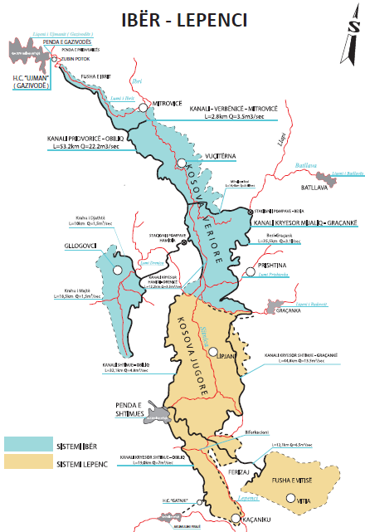 | The Iber Sub-system project was implemented in the 1980s and has been in operation for 40 years. The Lepenc Sub-system was developed to detailed design at the same time but was not implemented.  Rapid growth of urban areas and inadequate water resources in Central and South-East Kosovo, compounded by extremely dry periods and poor rainfall in the last 12 years have created critical water shortages and supply rationing in Regional Water Companies (RWCs) service areas. The objective of the Lepenc hydro system, Phase I is to provide a secure water supply for the immediate needs of the over 400,000 people living in the project area, which is shown in Figure 2.
Figure 2 - Regional Water Company Service Areas  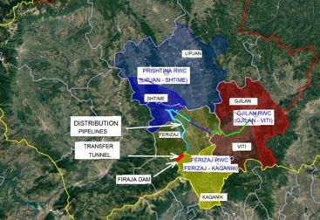 | The Ministry of Environment and Infrastructure, with assistance from the European Bank for Reconstruction and Development (EBRD), commissioned a study in 2017 to review and update the plans to develop the Lepenc river with a diversion dam on the Lepenc river at Firaja and a storage dam in a valley just west of Shtime. In early 2020 the study reported that the 1970s scheme remained valid in principle but required substantial changes to accommodate the expansion of the Southern towns. It recommended that the project be implanted in two phases.

The Phase 1 Lepenc system is designed to divert 1 m3/s from the Lepenc river for treatment by the three Regional Water Companies (RWCs) who provide drinking water to over 400,000 people in the 9 municipalities in Eastern and Southern Kosovo, 40% of whom lack proper access to public water, together with the requirements of their associated commercial and institutional consumers. It comprises:
- a 34.5 m high diversion dam at Firaja impounding a total volume of 7 million m³ comprising live storage of 4.75 million m³.
- a 4.2 km transfer tunnel from Firaja dam to Gacke
- about 70 km of untreated water conveyor pipelines from Gacke pipelines to head tanks at Shtime, Ferizaj and Gjilan.

The overall layout of the scheme components is shown in Figure 3.

Figure 3 - Layout of the Phase 1 Lepenc system
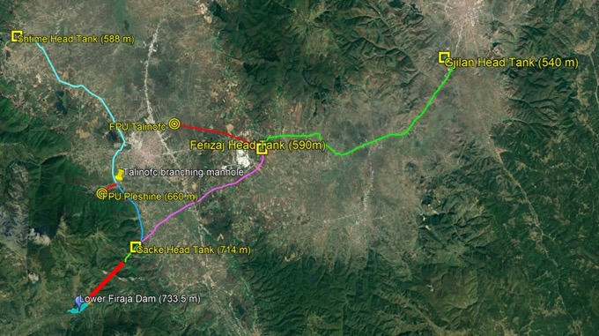

The hydrological evaluation of the Lepenc river at the Firaja dam for the 2017 feasibility study was based on:
- The hydrological study of the original detailed design of Lepenc Sub-Project in the 1970’s, prepared by ENERGOPROJEKT
- The 1986 ENERGOPROJEKT revised hydrological report for Lepenc river at the Firaja dam axis
- Available hydrometeorological data for the period after 1986
- New data collected by the Kosovo Hydrometeorological Institute after 2006
- Additional measurements made during the feasibility study on the temporary hydrometeorological stations installed in Kacanik (Nerodime river), Brod (Lepenc river) and Hani I Elezit (Lepenc river).

The findings for four characteristic hydrometric stations Lepenc river are summarized in Table 1 and the average monthly flows at Firaja are presented in Table 2
Table 1 - Characteristic Lepenc river flows
Average annual flow | Hani I Elezit | Brod | Firaja (dam axis) | Kacanik (Nerodime river)
average year, Q₀,_{59%} | 8.83 m³/s | 5.04 m³/s | 4.37 m³/s | 1.895 m³/s
dry year Q₀,_{75%} | 7.39 m³/s | 4.22 m³/s | 3.66 m³/s | 1.404 m³/s

Table 2 - Monthly annual flow rate at Lower Firaja (m³/s)
Months | J | F | M | A | M | J | J | A | S | O | N | D
Q_{o}(m³/s) | 4.7 | 4.8 | 5.8 | 7.0 | 10.3 | 7.1 | 4.2 | 2.5 | 2.7 | 3.5 | 4.7 | 4.9

The ecological flow following the Kosovo legislation for Firaja dam axis will be:
Q_{ecol} = 0,52 m³/s for the period May – October
Q_{ecol} = 0,822 m³/s for the period November – April

Potential Water Related Trans-Boundary Impacts

The Lepenc River flows beyond the territory of Kosovo, into North Macedonia, where it joins the River Vardar. This poses transboundary issues that need to be resolved through active and open communication between Ministry of Environment of Kosovo and Ministry of Environment of Macedonia. Abstraction of water may bring about tension between residents of both countries. The diversion of an estimated 31 Million m³ / year in Phase 1 from the current average annual flow of 290 million m³ into North Macedonia is unlikely to have significant detrimental impact on the North Macedonian side .

The flow in the Lepenc at Firaja contributes just under half of the trans-boundary flow into North Macedonia, just downstream of Hani I Elezit. The overall reduction in the average annual flow is expected to be 13.5% of the dry year flow and 11.3% of the flow in an average year. The ecological flow requirement means that trans-boundary flows in the driest months will not be reduced and may even benefit from the storage at the Firaja dam. The impact of the scheme on the 50% of the trans-boundary flow coming from the catchment upstream of the Firaja dam will be greatest in the Autumn, when the reservoir is refilling, then barely noticeable during Winter and Spring.

Mitigation measures
- Continuing open dialog commenced in October 2022 between Kosovo and North Macedonia about Kosovo’s intention to construct the water supply scheme, providing information regarding this scheme and requesting the opinion/acceptance to the planned investments
- Further developing the cross-border dialog of municipalities supported by the EU within the IPA Cross-Border Cooperation Programme Montenegro-Kosovo 2014-2020.
- Putting in place reasonable mechanisms to ensure that the project will not compromise the quality and quantity of water available for consumers downstream.

https://cbc-mne-kos.org/contact-us-3/

